There are 3 folders to hold flat files
- C:\EDI where incoming flat file is stored and its name is predefined
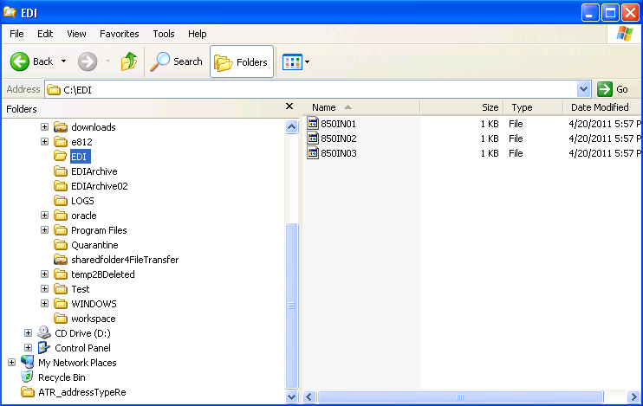
- For this example, file extension is not used
- EDIArchive: to store combined file
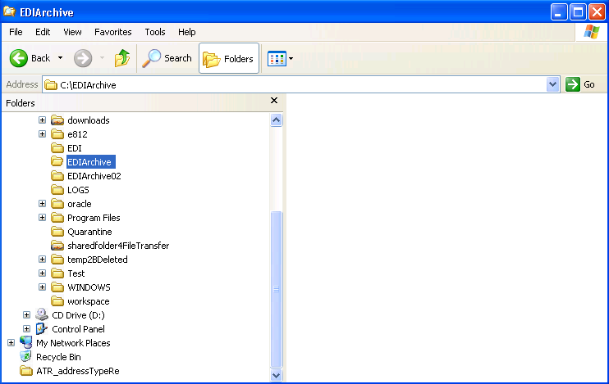

- EDIArchive02 to save the original files after combined
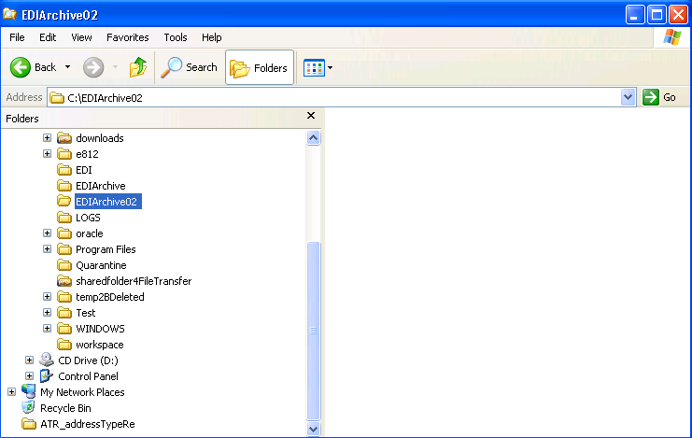

- Example of incoming flat files
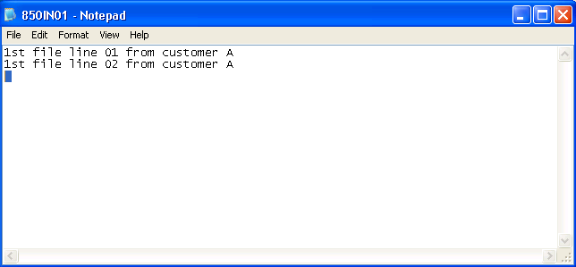
- Make it sure that the last line contains return carriage or new line character. For this example, cursor is located at 3rd line
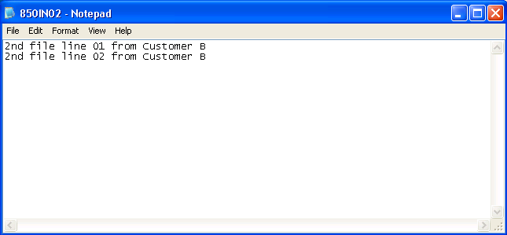
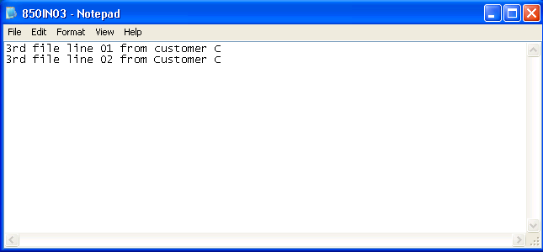

- Run “Combine Flat File”
Combine Flat File
evt_SourceFile_EXEP
evt_TargetFile_EXEP
evt_mnFirstFile
evt_mnLastFile_SEQ
evt_szSeqInString_DL01
evt_mnExistenceFlag
evt_ErrorCode
evt_DataItem
evt_Archive_EXEP
evt_OutputDateToday
OPT: Using Defaults
0001 //
0002 // If possible, create a table to write how flat files are handled with date,
0003 // sequence and audit information. Since for Data Exchange there are more than
0004 // 2 parties are involved so it is advisable to do so.
0005 //
0006 // If a new file name does exist then move it to archive location with
0007 // meaningful file name (850INALL_ddMMMyy_SEQ or
0008 // 850INALL_ddmmyyyy_uniquenumber)
0009 //
0010 VA evt_TargetFile_EXEP = "C:\EDI\850INALL"
0011 Operating System File Operations Delete, Rename, File Exists
"E" -> BF cActionCode
VA evt_TargetFile_EXEP <> BF szFileName1
"1" -> BF cSetOneWorldErrorFlag01
VA evt_mnExistenceFlag <- BF mnErrorCodeReturned
0012 If VA evt_mnExistenceFlag is equal to <Zero>
0013 //
0014 Convert Date To String Based On Format Code
SL DateToday -> BF jdInputDate_DT
"3" -> BF cOutputFormatCode_EV01
VA evt_OutputDateToday <- BF szOutputDateString_DL01
0015 VA evt_Archive_EXEP = concat('C:\EDIARCHIVE\850INALL_',[VA evt_OutputDateToday])
0016 Delete Or Copy Flat File
VA evt_TargetFile_EXEP -> BF szOriginalFlatFile
VA evt_Archive_EXEP -> BF szNewFlatFile
"2" -> BF cActionOnFlatFiles
<Zero> -> BF cSuppressErrorMessage
VA evt_ErrorCode <- BF cErrorCode
VA evt_DataItem <- BF szErrorMessage
0017 If VA evt_DataItem is equal to <Blank>
0018 Delete Or Copy Flat File
VA evt_TargetFile_EXEP -> BF szOriginalFlatFile
"1" -> BF cActionOnFlatFiles
<Zero> -> BF cSuppressErrorMessage
VA evt_ErrorCode <- BF cErrorCode
VA evt_DataItem <- BF szErrorMessage
0019 End If
0020 //
0021 End If
0022 //
0023 // Business scenario: Incoming file name is 850IN01 through 850IN99
0024 VA evt_mnFirstFile = "1"
0025 VA evt_mnLastFile_SEQ = "99"
0026 While VA evt_mnFirstFile is less than or equal to VA evt_mnLastFile_SEQ
0027 //
0028 // 1. Convert math numeric to string value to build source flat file name with
0029 // path
0030 //
0031 Convert Math_Numeric To String
VA evt_mnFirstFile -> BF mnMathNumeric01
VA evt_szSeqInString_DL01 <- BF szString
0032 VA evt_szSeqInString_DL01 = lpad([VA evt_szSeqInString_DL01],"0",2)
0033 //
0034 // 2. Source Flat File Name
0035 VA evt_SourceFile_EXEP = concat('C:\EDI\850IN',[VA evt_szSeqInString_DL01])
0036 //
0037 // 3. Verify existence
0038 Operating System File Operations Delete, Rename, File Exists
"E" -> BF cActionCode
VA evt_SourceFile_EXEP <> BF szFileName1
"1" -> BF cSetOneWorldErrorFlag01
VA evt_mnExistenceFlag <- BF mnErrorCodeReturned
0039 //
0040 // 4. If there is such a file then copy it to a single file name (e.g.,
0041 // 850INALL)
0042 If VA evt_mnExistenceFlag is equal to <Zero>
0043 Delete Or Copy Flat File
VA evt_SourceFile_EXEP <> BF szOriginalFlatFile
VA evt_TargetFile_EXEP -> BF szNewFlatFile
"2" -> BF cActionOnFlatFiles
<Zero> -> BF cSuppressErrorMessage
VA evt_ErrorCode <- BF cErrorCode
VA evt_DataItem <- BF szErrorMessage
0044 //
0045 // 5. If it is combined, then move the original file into archive location
0046 If VA evt_ErrorCode is not equal to "1"
0047 VA evt_TargetFile_EXEP = concat('C:\EDIArchive02\850IN',[VA evt_szSeqInString_DL01])
0048 Delete Or Copy Flat File
VA evt_SourceFile_EXEP -> BF szOriginalFlatFile
VA evt_TargetFile_EXEP -> BF szNewFlatFile
"2" -> BF cActionOnFlatFiles
<Zero> -> BF cSuppressErrorMessage
VA evt_ErrorCode <- BF cErrorCode
VA evt_DataItem <- BF szErrorMessage
0049 If VA evt_ErrorCode is not equal to "1"
0050 // Delete it from the original location
0051 Delete Or Copy Flat File
VA evt_SourceFile_EXEP -> BF szOriginalFlatFile
"1" -> BF cActionOnFlatFiles
<Zero> -> BF cSuppressErrorMessage
VA evt_ErrorCode <- BF cErrorCode
VA evt_DataItem <- BF szErrorMessage
0052 End If
0053 // set combile file - target file to convert
0054 VA evt_TargetFile_EXEP = "C:\EDI\850INALL"
0055 End If
0056 End If
0057 //
0058 VA evt_mnFirstFile = [VA evt_mnFirstFile]+1
0059 End While
0060 //

- Verify a combined file is created in EDI folder
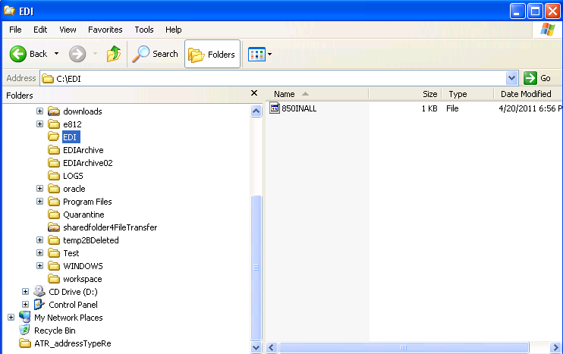

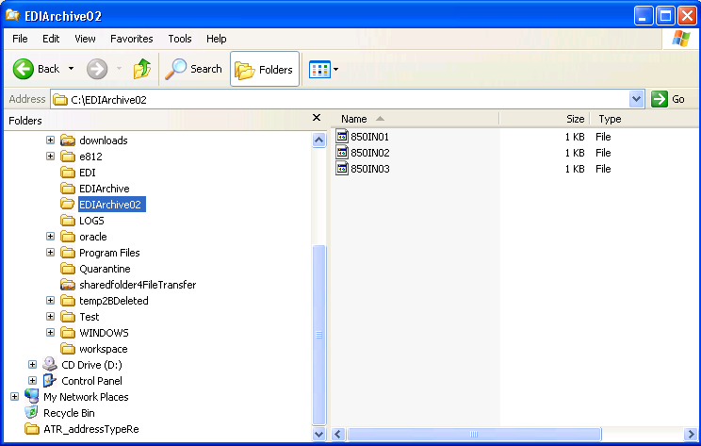

- 3 different flat files are combined into one file 850INALL (this file name matched path and file name defined in P47002)
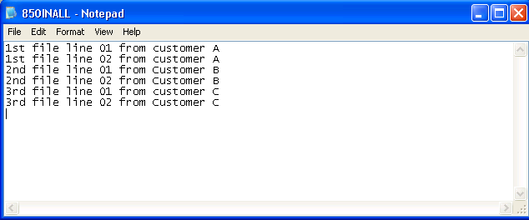

- Run conversion application

