Business Scenario:
In creating a new address book master information, you want to create an error message as below,
"User 'UserID' is not allowed to create a new address book information when search type is 'SearchType' and country code is 'CountryCode'. Inform your manager.
Steps to implement this:
1. Create Data Structure 'DE5501012' to handle variables szUserID, szSearchType and szCountryCode using DD Alias USER, AT1 and CTR
2. Create DD item '5501013' to call Error Code
3. Create Business Function B5501012 to call API jdeSetGBRErrorSubText ()
4. Call B5501012 from P01012 (Address Book) to indicate warning message on screen

- Create Data Structure DE5501012
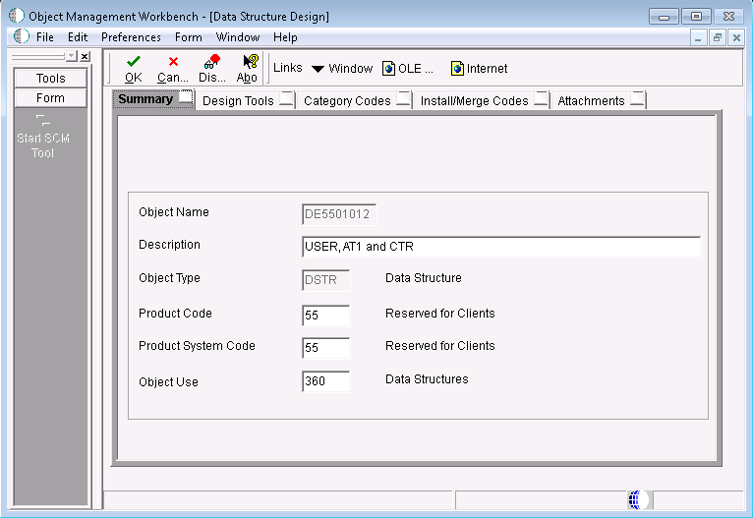

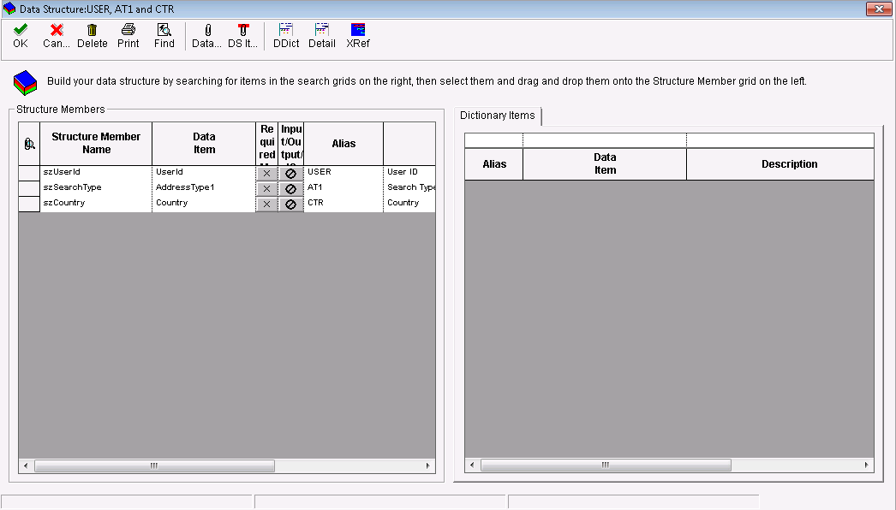

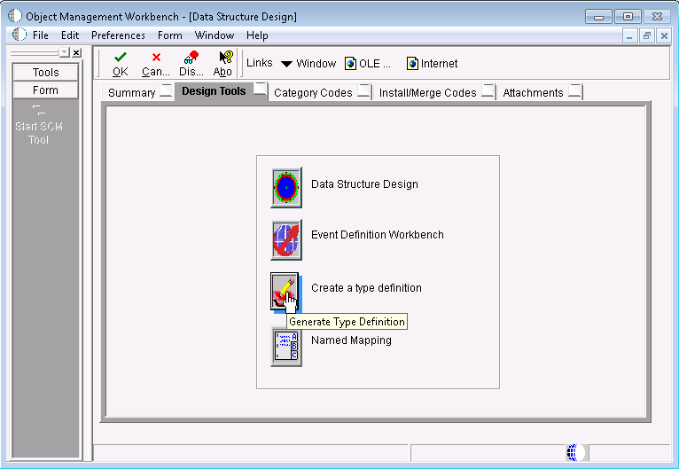
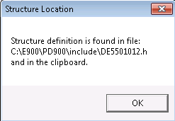
- This information is to be used in header file (e.g., B5501012.h)

- Create Error Item through P92002
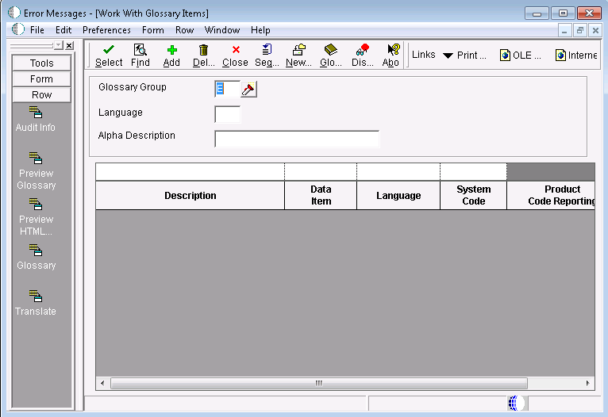
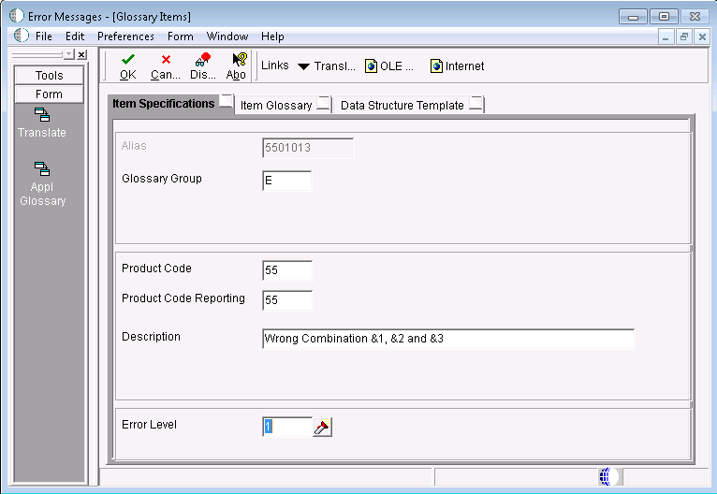
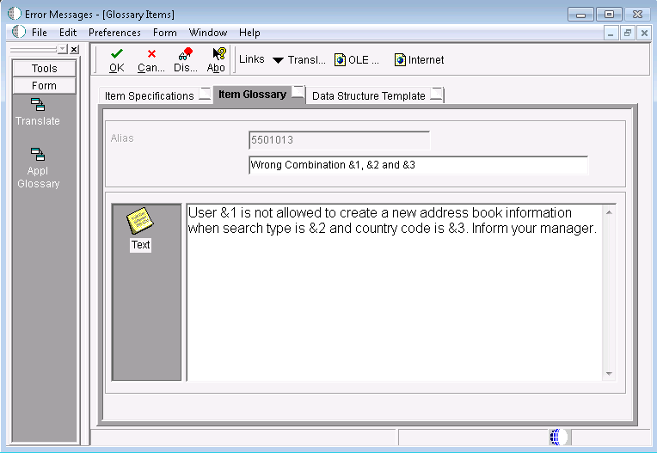
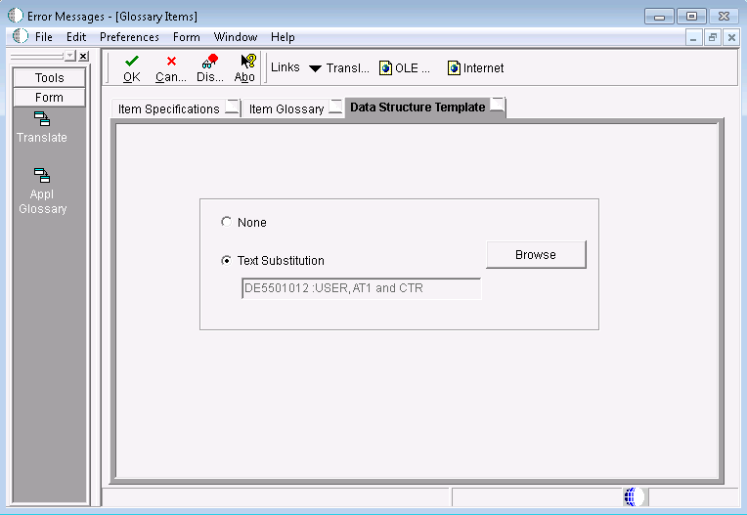

- Create BSFN B5501012.h and B5501012.c and place it into Include and Source folder respectively
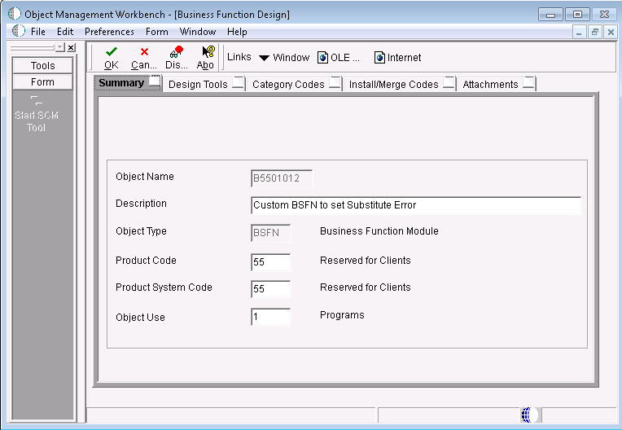

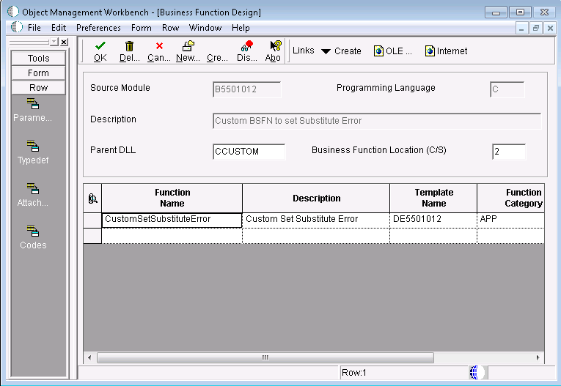
B5501012.h

/*****************************************************************************
* Header File: b5501012.h
*
* Description: CustomSetSubstituteError
*
* History:
* Date Programmer SAR# - Description
* ---------- ---------- -------------------------------------------
* Author 01/05/2012 Unknown - Created
*
*
* Copyright (c) J.D. Edwards World Source Company, 1996
*
* This unpublished material is proprietary to J.D. Edwards World Source
* Company. All rights reserved. The methods and techniques described
* herein are considered trade secrets and/or confidential. Reproduction
* or distribution, in whole or in part, is forbidden except by express
* written permission of J.D. Edwards World Source Company.
****************************************************************************/

#ifndef __B5501012_H
#define __B5501012_H

/*****************************************************************************
* Table Header Inclusions
****************************************************************************/
#include <jdeapp.h>

/*****************************************************************************
* External Business Function Header Inclusions
****************************************************************************/

/*****************************************************************************
* Global Definitions
****************************************************************************/

/*****************************************************************************
* Structure Definitions
****************************************************************************/
/*****************************************
* TYPEDEF for Data Structure
* DE5501012 : USER, AT1 and CTR
*
* Copyright Oracle USA
*
* This is a JDEdwards EnterpriseOne generated file.
* Do not modify this file.
* Only re-generate with the appropriate tool.
* Generation Date : 04/01/2012
*/

#ifndef DATASTRUCTURE_DE5501012
#define DATASTRUCTURE_DE5501012

typedef struct tagDSDE5501012
{
JCHAR szUserId[11];
JCHAR szSearchType[4];
JCHAR szCountry[4];
} DSDE5501012 , *LPDSDE5501012;

#define IDERRszUserId_1 1L
#define IDERRszSearchType_2 2L
#define IDERRszCountry_3 3L

#endif /* DATASTRUCTURE_DE5501012 */

/*****************************************************************************
* Source Preprocessor Definitions
****************************************************************************/
#if defined (JDEBFRTN)
#undef JDEBFRTN
#endif

#if defined (WIN32)
#if defined (WIN32)
#define JDEBFRTN(r) __declspec(dllexport) r
#else
#define JDEBFRTN(r) __declspec(dllimport) r
#endif
#else
#define JDEBFRTN(r) r
#endif

/*****************************************************************************
* Business Function Prototypes
****************************************************************************/
JDEBFRTN (ID) JDEBFWINAPI CustomSetSubstituteError (LPBHVRCOM lpBhvrCom, LPVOID lpVoid, LPDSDE5501012 lpDS);

/*****************************************************************************
* Internal Function Prototypes
****************************************************************************/

#endif /* __B5501012_H */

B5501012.c
#include <jde.h>

#define b5501012_c

/*****************************************************************************
* Source File: b5501012
*
* Description: Custom set Substitue Error
*
* History:
* Date Programmer SAR# - Description
* ---------- ---------- -------------------------------------------
* Author 01/05/2012 Unknown - Created
*
* Copyright (c) J.D. Edwards World Source Company, 1996
*
* This unpublished material is proprietary to J.D. Edwards World Source Company.
* All rights reserved. The methods and techniques described herein are
* considered trade secrets and/or confidential. Reproduction or
* distribution, in whole or in part, is forbidden except by express
* written permission of J.D. Edwards World Source Company.
****************************************************************************/
/**************************************************************************
* Notes:
*
**************************************************************************/

#include <b5501012.h>

/**************************************************************************
* Business Function: CustomSetSubstituteError
*
* Description: Custom Set Substitute Error
*
* Parameters:
* LPBHVRCOM lpBhvrCom Business Function Communications
* LPVOID lpVoid Void Parameter - DO NOT USE!
* LPDSD0800301 lpDS Parameter Data Structure Pointer
*
*************************************************************************/

JDEBFRTN (ID) JDEBFWINAPI CustomSetSubstituteError (LPBHVRCOM lpBhvrCom, LPVOID lpVoid, LPDSDE5501012 lpDS)
{
/************************************************************************
* Variable declarations
************************************************************************/

/************************************************************************
* Declare structures
************************************************************************/
DSDE5501012 dsDE5501012; /* text substitution error*/

/************************************************************************
* Declare pointers
************************************************************************/

/************************************************************************
* Check for NULL pointers
************************************************************************/
if ((lpBhvrCom == (LPBHVRCOM) NULL) ||
(lpVoid == (LPVOID) NULL) ||
(lpDS == (LPDSDE5501012) NULL))
{
jdeErrorSet (lpBhvrCom, lpVoid, (ID) 0, _J("4363"), (LPVOID) NULL);
return ER_ERROR;
}

/************************************************************************
* Set pointers
************************************************************************/

/************************************************************************
* Main Processing
************************************************************************/

memset((void *)(&dsDE5501012), (int)(_J('\0')), sizeof(dsDE5501012));
jdeStrncpy(dsDE5501012.szUserId, (const JCHAR *)(lpDS->szUserId),DIM(dsDE5501012.szUserId));
jdeStrncpy(dsDE5501012.szSearchType, (const JCHAR *)(lpDS->szSearchType), DIM(dsDE5501012.szSearchType));
jdeStrncpy(dsDE5501012.szCountry, (const JCHAR *)(lpDS->szCountry), DIM(dsDE5501012.szCountry));

jdeSetGBRErrorSubText(lpBhvrCom, lpVoid,0,_J("5501013"), &dsDE5501012);
/************************************************************************
* Function Clean Up
************************************************************************/
return (ER_SUCCESS);
}

/* Internal function comment block */
/**************************************************************************
* Function: Ixxxxxxx_a // Replace "xxxxxxx" with source file number
* // and "a" with the function name
* Notes:
*
* Returns:
*
* Parameters:
**************************************************************************/

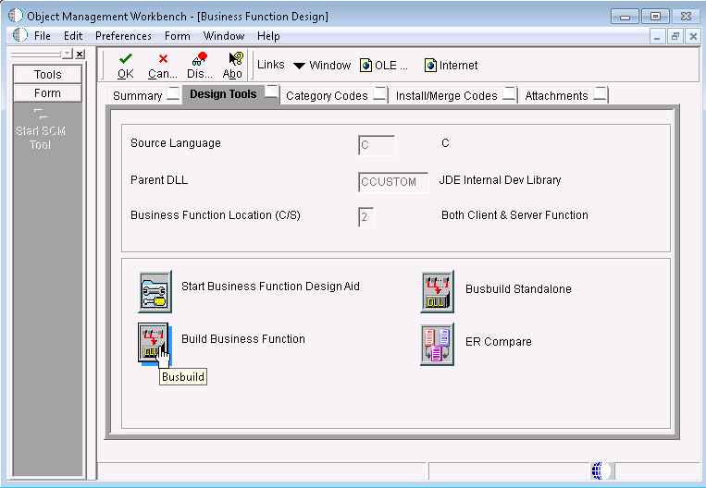

- Implement it in application
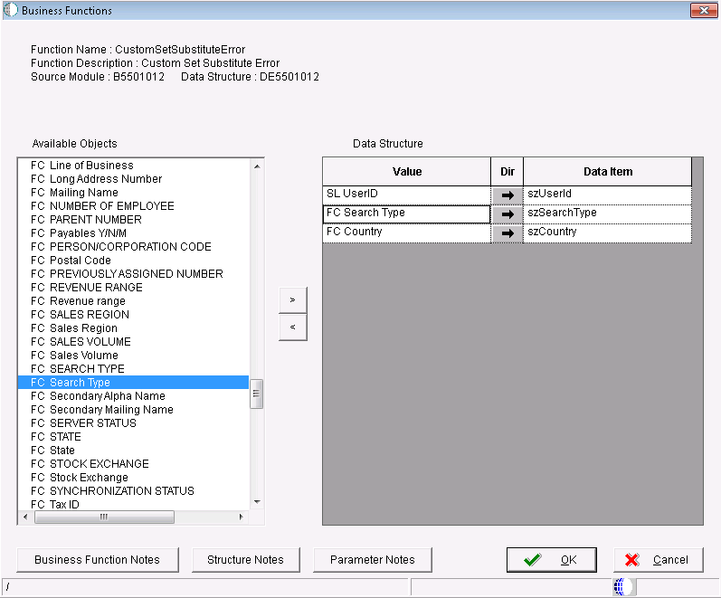

- Test it

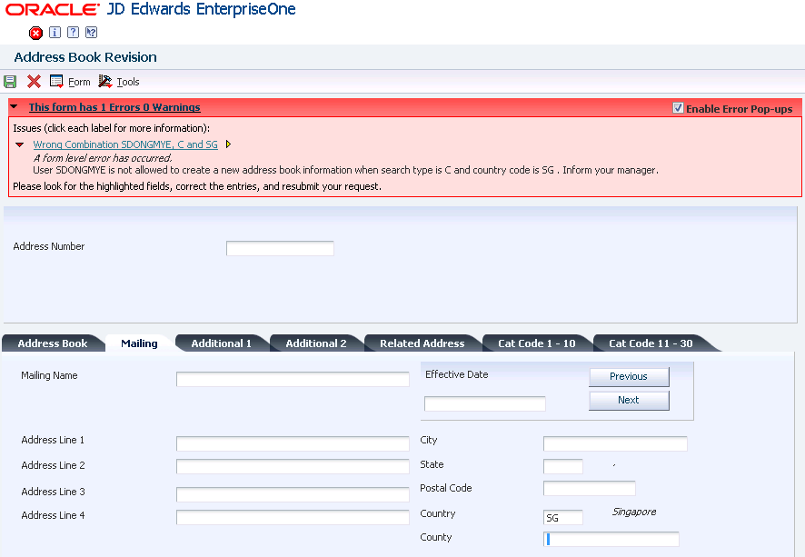

 | This form has 1 Errors 0 Warnings | Enable Error Pop-ups

Issues (click each label for more information):
Wrong Combination SDONGMYE, C and SG
A form level error has occurred.
User SDONGMYE is not allowed to create a new address book information when search type is C and country code is SG . Inform your manager.
ER Details:
Form | P01012_W01012A
Control Id | 56
Control Title | Country
Event | Control is Exited
Line No | 2

BSFN Details:
Source File | C:\E900\PD900\source\B5501012.c
Source Line | 84
Error ID | 5501013

Please look for the highlighted fields, correct the entries, and resubmit your request.

